Project Design Phase-II
Technology Stack (Architecture & Stack)

Date | 4 FEB 2026
Team ID | LTVIP2026TMIDS87433
Project Name | Rain Prediction Pipeline Flask
Maximum Marks | 4 Marks

Technical Architecture:
The Deliverable shall include the architectural diagram as below and the information as per the table1 & table 2

Example: Rainfall Prediction Pipeline using Machine Learning and Flask
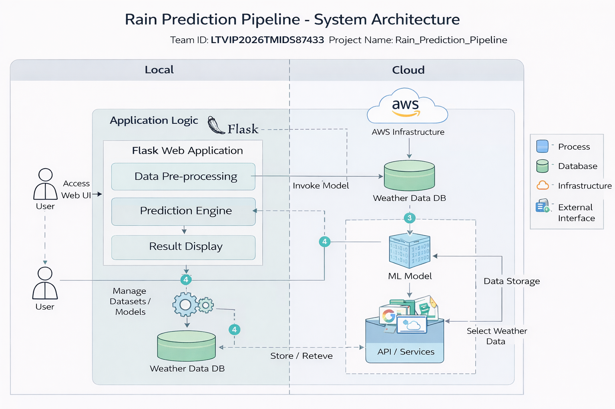
Table-1: Components & Technologies:
S.No | Component | Description | Technology
 | User Interface | Web interface for entering weather parameters and viewing prediction results | HTML, CSS, JavaScript
 | Application Logic-1 | Handles user requests and routes in Flask | Python,Flask
 | Application Logic-2 | Data preprocessing (cleaning, feature selection) | Python, Pandas, NumPy
 | Application Logic-3 | ML prediction logic
  Scikit-learn
 | Database | Stores weather inputs and prediction results | SQLite / CSV
 | Cloud Database | Cloud storage for datasets and predictions | AWS S3 / MongoDB Atlas (optional)
 | File Storage | Stores trained ML model and datasets | Local File System
 | External API-1 | Optional weather data source | OpenWeather API
 | External API-2 | Not used | -----
 | Machine Learning Model | Predicts rainfall based on input parameters | Random Forest / Logistic Regression
 | Infrastructure (Server) | Application hosting and execution | Localhost

Table-2: Application Characteristics:
S.No | Characteristics | Description | Technology
 | Open-Source Frameworks | Frameworks and libraries used in project | Flask, Pandas, NumPy, Scikit-learn
 | Security Implementations | Input validation and basic application security | Flask validation, HTTPS (deployment), Password hashing (optional)
 | Scalable Architecture | Follows 3-tier architecture (UI, Application Logic, ML Model) | Flask + ML Pipeline
 | Availability | Application available while server is running | Localhost
 | Performance | Fast prediction due to lightweight ML model and Flask backend | Python, Scikit-learn

